#### Purpose of implementing ZCFPERFCHECK_V2

The purpose of ZCFPERFCHECK_V2 is to extract data from an AS ABAP system that can be used for further analysis to determine:

1. If there are Z programs running longer than the acceptable maximum runtime
2. Based on the ST10 output, what could be causing the Z programs to run for longer than necessary
3. The most important adjustments to make to the Z programs identified, that would provide a reduction in system resource utilization and the biggest improvement in runtime.

#### Implementation steps

Note:

* Please use the naming convention provided in the document and ignore the naming in the screenshots.
* If there is any specific naming conventions that need to be followed in your system, please adapt the naming to follow your convention.

1. In transaction SE80, create a new program called ZCFPERFCHECK_V2 (Please note that the screenshots have the old name)

Click **Yes**

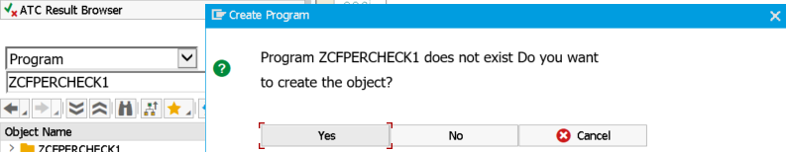

Specify the program name

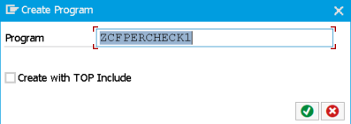

Specify the title and set the Status to Test Program

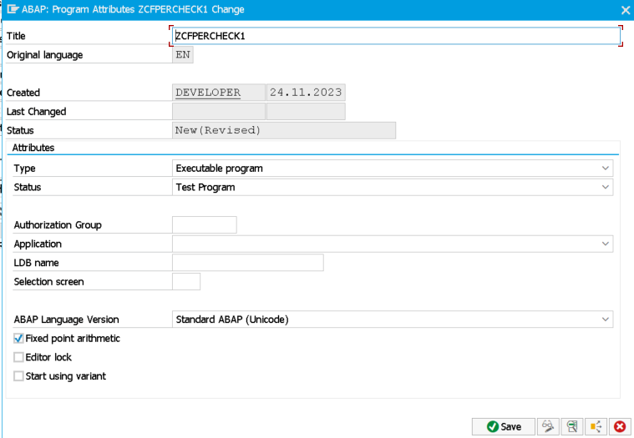

Choose **Local Object**

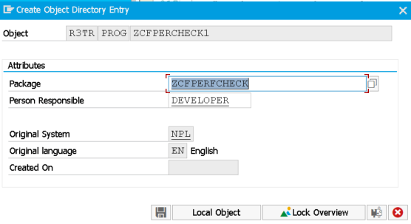

1. Double click on **ZCFPERFCHECK_V2** under **Object Name** and then click edit in order to paste in the provided source code.

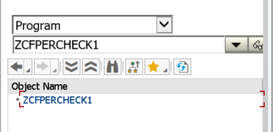

1. Save the program and execute a check to verify that there are no errors produces in your system. If there are any errors, please let me know.

Click **Ctrl+F2** or the **Check** button on the left of the **Activate** button.

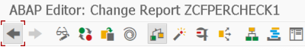

1. Under the constants section you will find values that can be adjusted. The following values should be adjusted based on your system usage policies

gc_program_name_prefix has been set to a value that ensures that only Z programs are analyzed. If you have a specific Z program that needs to be analyzed then you can replace Z% to the program name itself.

gc_min_bgd_job_runtime_in_sec can be adjusted to retrieve information on background jobs where Z programs are executed that run longer than a minimum amount of time in seconds

gc_file_download_path indicates the location that the output file will be saved to and this should be changed to a location where you are able to download files to.

gc_download_source_code can be set to **yes** or **no**. If there is a policy against downloading the Z program source code and providing the content to a third party, then please set this value to **no** to ensure no source code is downloaded.

The rest of the values can be left as is, unless you have a specific convention that you need to follow.

1. Activate (Ctrl+F3) and Execute (F8) the program.





Please note that the execution of the program can take a while, depending on how many Z programs need to be analyzed in the system

Click **Allow** to download the output file that has been generated. This is the file that I will need in order to check for any issues with the Z program and any long running background jobs that are executing the Z programs.

